## **Power BI Project Summary: Employment Trends and Industry Analysis Across UK Cities**

Objective:

Analyze the employment trends across various industries in multiple UK cities between 2011 and 2014, identifying growth and decline patterns by industry sector.

Key Features:

* Data Overview:
  + Employment data by city and industry.
  + Jobs count for 2011 and 2014.
  + Change in number of jobs and percentage change.
  + Industry classification based on SIC code.
* Visualizations:
  + Map Visualization: Display cities with employment size indicators and color-coded by job growth or decline.
  + Bar/Column Charts: Show industry-wise job changes and percentage changes for selected cities.
  + Trend Analysis: Compare job growth over time across different industries.
  + Slicer/Filters: Filter data by city, industry, and job change (growth or decline).
  + Summary Cards: Highlight top growing industries and cities with highest job increase.
* Insights to Highlight:
  + Cities and industries with highest job growth (e.g., Aberdeen's administrative and support services growth).
  + Cities and industries with largest declines (e.g., industries like education or certain manufacturing sectors).
  + Overall employment trends by sector and geography.
  + Correlations between industry type and growth patterns.

Data Preparation Steps:

* Clean and normalize data fields for consistent analysis.
* Create calculated columns for % change if not already provided.
* Categorize industries into broader sectors if needed for comparison.
* Ensure geographic data supports mapping features in Power BI.

Outcome:  
A comprehensive Power BI dashboard report enabling stakeholders to understand regional economic shifts, support strategic planning for workforce development, and identify opportunities or challenges in specific industries and locations.

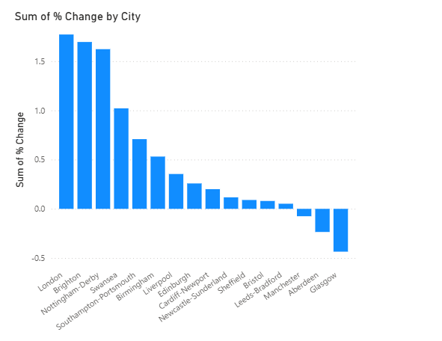

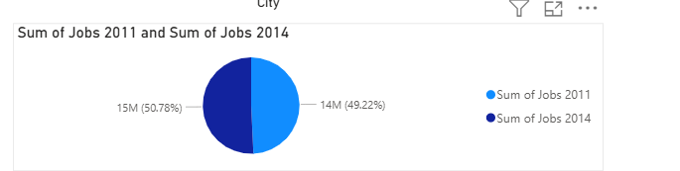

Link - https://docs.google.com/spreadsheets/d/1X_BCwEf8dLoLcwJ4KwjT-iue0ADjLImYS0qvKwfmmDE/edit?usp=sharing

* Devesh Dhyani